Pearland MLK Celebration Committee
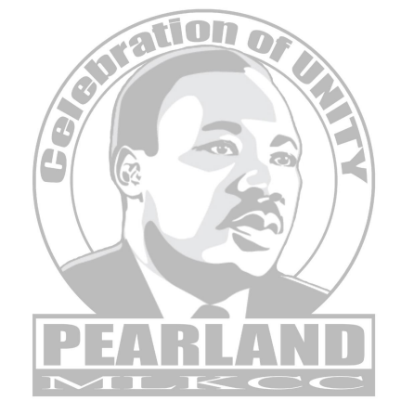
Dear Valued Community Member:
The great Martin Luther King, Jr. stated “the ultimate measure of a man is not where he stands in moments of comfort and convenience, but where he stands at times of challenge and controversy.” In the current unsettled social and political climate, this quote is relevant.
There are many ways in which Martin Luther King Jr.’s birthday is celebrated, and we invite you to join the Pearland MLK Celebration Committee for our special festivities. While we are already planning our Scholarship and Awards Banquet, we need your help to accomplish our fundraising goals. The Pearland MLK Sixth Annual Scholarship and Awards Banquet will be held Saturday, January 7, 2023, at 6:00 PM at the Hilton Garden Inn, 12101 Shadow Creek Pkwy, Pearland, Texas.
You can help raise funds to enable youth in our community to attend college and support our service recognition and celebration activities and provide community awareness information programs which serve as a public platform to hear from our leaders, community businesses and organizations. Your support is key in bringing awareness to the Pearland community of the importance of the life lived by this community leader and activist.
Would you consider donating to help us achieve our mission?
We thank you in advance for your support! Your donation is greatly appreciated and will be used to allow the Pearland MLK Celebration Committee to host a weekend full of celebration, information, recognition, scholarship, and fellowship. You can donate online at www.pearlandmlkcc.org, call us at (832) 603-3584, or send a check to Pearland MLKCC, PO Box 841458, Pearland, TX, 77584. Pearland MLKCC is a 501(c) 3 organization.
With warm regards,
Pearland MLKCC Sponsorship Committee

